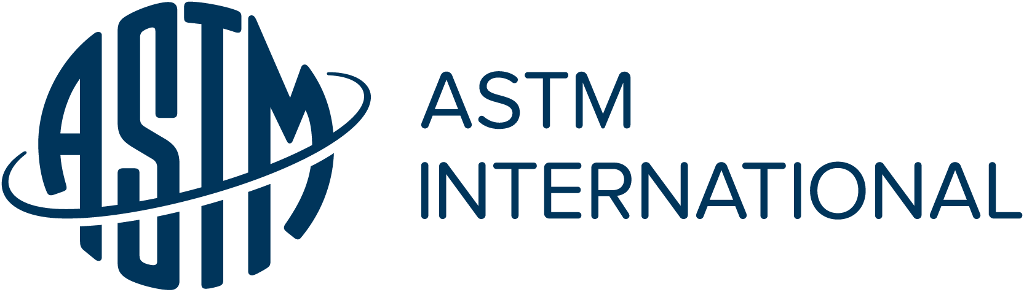
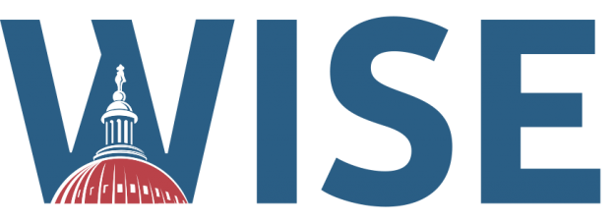

WASHINGTON INTERNSHIPS
FOR STUDENTS OF ENGINEERING

2024 Summer Program

(June 2 - August 3, 2024)

Application Instructions

Applicant must be:

(1) a Junior or Senior engineering or scientific student or a recent graduate beginning study in a graduate-level, science/engineering/technology policy-related program;

(2) a citizen or legal permanent resident of the United States; and

(3) a student member of ASTM International

Only completed applications will be considered. A complete application includes the following:

(1) a completed application form (two pages and attached essays);

(2) a copy of your official transcript(s); and

(3) two letters of reference (at least one of which must be from an engineering faculty member who supervised your work)

Complete applications may be sent electronically to:

Travis Murdock

tmurdock@astm.org

Transcripts requiring a mailing address can be sent to:

Travis Murdock

ASTM International

100 Barr Harbor Drive

West Conshohocken, PA 19428

Deadline:

All material must be submitted or postmarked by February 1, 2024

For more information: www.wise-intern.org

APPLICATION FOR ASTM-WASHINGTON INTERNSHIPS
FOR STUDENTS OF ENGINEERING (WISE)

Name

Address

Phone Number

Social Security Number
Note: SSN is required for purposes of arranging meetings in most federal facilities

Citizenship DOB

E-Mail Address

University in which enrolled

Expected date of graduation

Major & Minor

Special areas of interest

GPA (overall) GPA (major field)

ASTM International Student Member #

How did you find out about the WISE Program?

Indicate two persons from whom references were requested:

Name

Professional Address

Phone Number

E-Mail Address

Name

Professional Address

Phone Number

E-Mail Address

- 1 -

ASTM-WISE APPLICATION FORM (Cont’d)

Emergency Contact Name

Contact Address

Contact Phone Number

List any student office(s) held (and year) along with any student or other extra-curricular activities in which you have participated in the last three-four years:

APPLICATION ESSAYS

Prepare and attach two short essays on the following topics. Each essay should be approximately 500 words (one page), single spaced, with 12-point type.

Essay 1: Why should engineers be concerned about public policy issues and what can
they contribute to the process?

Essay 2: What specific technology-related public policy issue would you like to explore
during the 10-week program and why?

There are no right or wrong answers. The essays are reviewed primarily as samples of your writing. They also help your sponsoring societies better understand your interests and your grasp of policy issues. If chosen for the WISE program, your answer to question (2) does not constitute a topic selection; topics will be finalized after consultation with your sponsoring society.

REFERENCE INFORMATION REQUEST

Each summer the WISE program brings undergraduate engineering students to Washington, D.C. to learn more about the relationship between government and the technical community. Interns attend 25-30 meetings with policy makers and complete a topic paper on a specific engineering-public policy issue of interest to both the student and the sponsoring organization. As part of the selection process, each applicant is requested to have two references to be included in his/her file.

Name of Applicant Last First

Name of Reference
Last First

Title

Department

Address

1. NARRATIVE COMMENTS: (Attach additional pages if desired)

2. QUALIFICATIONS: I would compare this student with others on a peer level as follows:

a. QUALITY OF ACADEMIC WORK
EXCELLENT GOOD FAIR POOR

b. COMMUNICATION SKILLS (ORAL):
EXCELLENT GOOD FAIR POOR

c. COMMUNICATION SKILLS (WRITTEN):
EXCELLENT GOOD FAIR POOR

d. INTERPERSONAL SKILLS:
EXCELLENT GOOD FAIR POOR

e. LEADERSHIP ABILITIES:
EXCELLENT GOOD FAIR POOR

f. MOTIVATION:
EXCELLENT GOOD FAIR POOR

g. MATURITY:
EXCELLENT GOOD FAIR POOR

STATEMENT OF CONFIDENTIALITY

My preparation of this reference is conditioned on the promise of WISE to hold my identity as author of these comments in confidence.

My preparation of this reference is NOT conditioned on the promise of WISE to hold my identity as author of these comments in confidence.

Signature of Respondent Date

RETURN COMPLETED REFERENCE TO:

Travis Murdock
ASTM International
100 Barr Harbor Drive
West Conshohocken, PA 19428
Tel: 610-832-9826
Email: tmurdock@astm.org

APPLICATION DEADLINE
ALL APPLICATION MATERIALS MUST BE POSTMARKED BY February 1, 2024

